

**2023-28**

**Strategic**

**Plan**

**Contents**

**Introduction**

**2**

**Vision**

**5**

**Purpose**

**5**

**The Strategy**

**7**

**Values**

**12**

**Implementation of the Strategy**

**13**



**Strategic Plan**

**2023-28**

**Introduction**

This is the Children’s Court Guardian

Agency’s five-year strategy for 2023- 2028.

It outlines the ambition the Agency has

set for the next five years, in delivering

a Children’s Court Guardian service

to those children who are subject to

public law and adoption proceedings in

Northern Ireland.

This strategy marks a watershed for the

Agency and builds on a 26-year history.

The Agency was established as, the

Northern Ireland Guardian Ad Litem

Agency in 1996, referred to as NIGALA,

with the central office base in Centre

House in Belfast.

With the commencement of the

implementation of The Adoption and

Children Act (2022), The Children’s

Court Guardian Agency for Northern

Ireland (Establishment and Constitution)

Order (Northern Ireland) 2023 came into

force on the 6th March 2023.

This changed the name of the Agency

from the Northern Ireland Guardian Ad

Litem Agency to the Children’s Court

Guardian Agency for Northern Ireland.

The Guardians Ad Litem will now be

known as Children’s Court Guardians.



**Strategic Plan**

**2023-28**

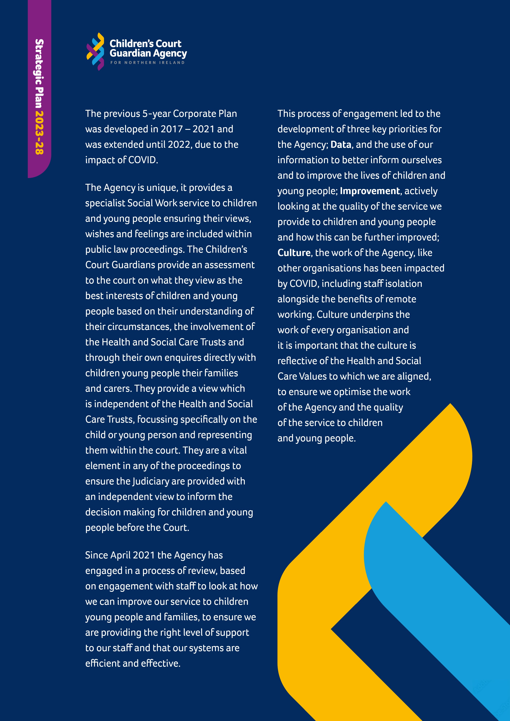

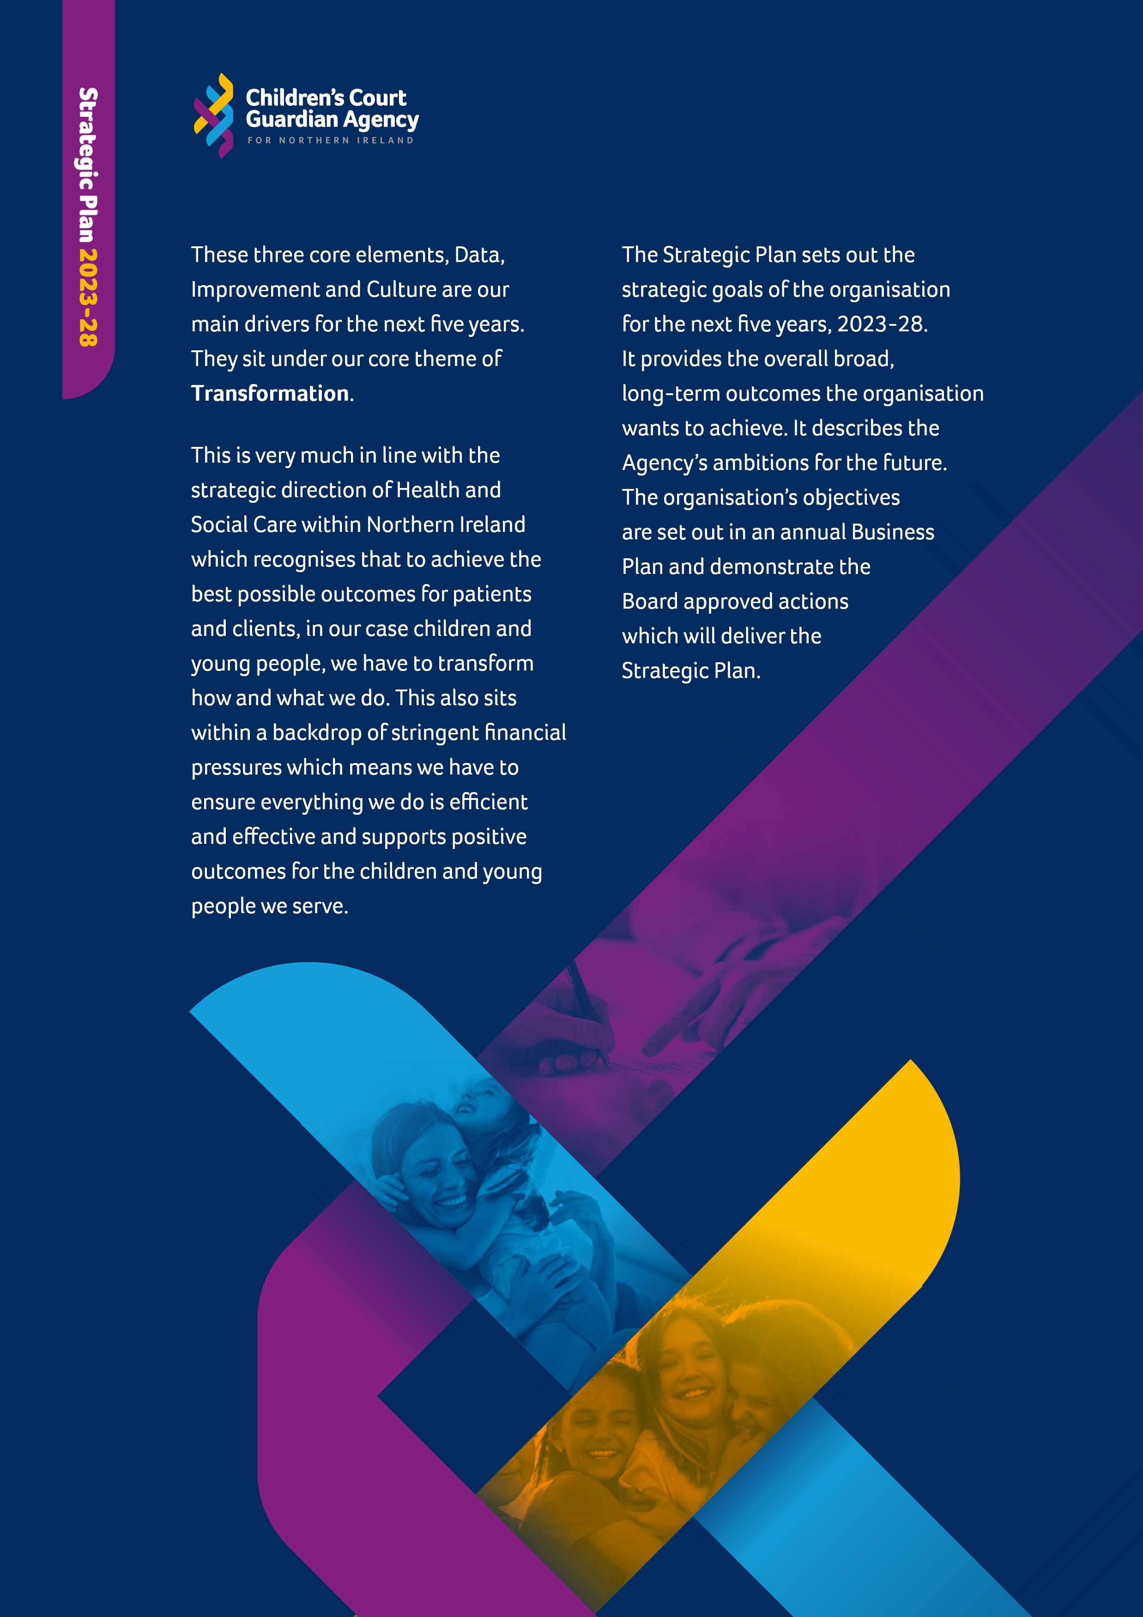

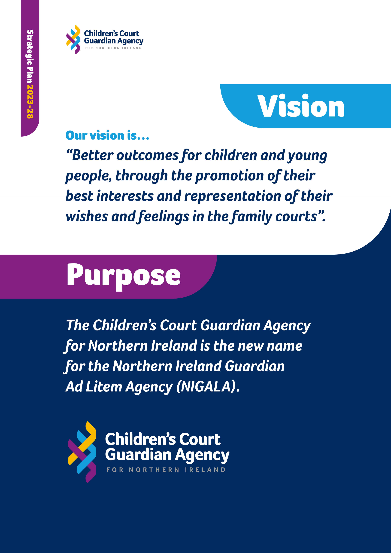

# Establishment and Constitution

NIGALA was originally established in 1995 by the then Department of Health and Social Services as a Special Agency using powers conferred on it by the Health and Personal Social Services (Special Agencies) (Northern Ireland) Order 1990. The constitution of NIGALA was set out in the Northern Ireland Guardian ad Litem Agency

(Establishment and Constitution) Order (NI) 1995, which came into operation on 1st December 1995.

The decision to change the name of the Agency was implemented by the Children’s Court Guardian Agency for

Northern Ireland (Establishment and

Constitution) Order (Northern Ireland) 2023, which came into operation on 6 March 2023.

# Function of the Agency

Following commencement of section

137 of the Adoption and Children Act

(Northern Ireland) 2022 on 13 February 2023, the guardian ad litem is now known as a **children’s court guardian**.

Our primary function is to ensure the availability of suitably qualified, professionally competent court guardians and their prompt allocation in public law and adoption proceedings, when an appointment has been made by the court.

**Strategic Plan**

**2023-28**

Article 60 of the Children (Northern Ireland) Order 1996 and Article 66 of the Adoption (Northern Ireland) Order 1987 govern the appointment of children’s court guardians. The children and young people involved in court proceedings will have a guardian who will get to know them and understand their circumstances in order to represent their feelings and wishes and promote their best interests.

# Court Rules

Article 4.12 of the Family Proceedings Rules (NI) 1996 outlines the powers and duties of a children’s court guardian in the family proceedings courts.

**The Agency** is a special agency and as a regional organisation is constituted as an Arm’s Length Body (ALB), funded by the Department of Health, with a statutory function to provide a Children’s Court Guardian service within the family courts. The Agency is responsible for the recruitment management, supervision, support, professional development, competence and monitoring of social work representation by children’s court guardians for children and young people who are the subject of public law and adoption applications.



**The Strategy**

Over the next five years the overarching

direction of the Agency is one of Transformation.

The Agency has agreed a number of strategic

drivers on which it will focus to transform itself.

The strategic themes give direction to the annual

business plan in the organisation. These themes

will shape what we do. The Agency has identified

a number of work areas to which it will apply the

themes in its business planning.

**The Strategic Drivers**

The three strategic drivers were identified

through a process of staff engagement and

review over the last two years. They are

Improvement, Data and Culture, each

of these will drive transformation

within the Agency in the key work

areas of the Agency. This is

depicted in the Strategic

diagram and underpins

the objectives for the

Agency over the next

five years.

**Strategic Plan**

**2023-28**

# Transformation

**We will transform the Agency in line with the strategic direction of health and social care services in a challenging economic environment.**

**Strategic Plan**

**2023-28**

Transformation will be responsive to diversity, demography, changing social work practice, developments in social work practice and structural reform.



**Data**

**Improvement**

**Culture**

**Strategic Drivers**

**Support**

**to staff**

**Children and**

**Young People**

**Systems**

**Influencing**

**Key strategic work Areas**

## Strategic Objectives

Our objectives are set out under the four key work areas which cover the main areas of the work of the Agency.

### 1. Children and young people

**Strategic Plan**

**2023-28**

### 2. Our staff

### 3. The systems we use and

**4. Our ability to influence children and young people’s policy and practice**



**1.**

**Children and Young People**

Representing the best interests and

voice of vulnerable children and

young people is the core of the work

within the Agency. We therefore seek

to engage with, and learn from, the

children and young people who have

had the support of a guardian in order

to obtain feedback on all aspects

of what we do and to enable us to

improve all aspects of our service.

We are building on the previous

work of the Northern Ireland Youth

Associates Board which met regularly

to give children and young people

the opportunity to tell us about what

matters to them when their family

situation is before the Family Court.

We will include them as we move

forward in developing a new strategy to

improve the invaluable participation of

children and young people in enabling

us to improve what we do. Our first

objective is based on this approach.

Objective 1:

**Children and Young People**

**•**

We will develop and implement

an engagement strategy for and

with children and young people

**•**

We will ensure that children and

young people’s voices are fully

represented in Court

**•**

We will use a co-production

methodology to include children

and young people’s views in

improving our practice and the

service.

**These key areas were agreed as part of our strategic planning process.**



**2.**

**Support to Staff**

Our staff, our team of guardians and

our corporate and business support

team, remain our most important asset.

The co-operation between these two

teams is vital to the achievement of

our aims in providing a high-quality

service to children and young people

in the family courts. We are committed

to ensuring continuing learning and

development opportunities to meet

the needs of our staff. Our system of

support to, supervision and monitoring

of staff in their challenging roles, is

designed to assist our workforce in

their commitment to excellence. This

includes working closely with our

Solicitor panel and our Trust colleagues

to ensure Guardians are up to date on

current practices.

We will help staff wellbeing through

continuing to access the regional

resources available through the

Business Services Organisation,

including the Inspire programme.

Our staff engagement process has

identified the challenge of improving

our culture and we will continue to

work towards the further development

of a positive and supportive culture

and to embed the collective leadership

approach. We have strengthened staff

supervision / team meetings and we will

continue to look at how we can further

the development of a positive and

supportive culture within the Agency.

Supporting our staff is therefore our

second objective.

Objective 2:

**Support to staff**

**•**

We will support staff through

learning and development

opportunities to provide a

quality service to children and

young people

**•**

We will support the health and

wellbeing of our staff

**•**

We will embed the HSC

collective leadership model to

support collaborative working

and team culture

**Strategic Plan**

**2023-28**



**3.**

**Systems and processes**

We all use systems and processes

to fulfil our roles

**.**

These include

governance, human resources, IT,

finance, policies and procedures for

practice. Improvements and changes

to meet requirements are continuous

so we need to ensure that everything

we do is as efficient and effective as

possible. This reduces duplication and

should improve everyone’s experience

of using a system or process. We need to

continually review these to ensure they

are fit for purpose and meet our current

requirements. Having an improvement

focus for all of our systems and processes

Is our third objective.

Objective 3:

**Systems and processes**

**•**

We will continually review

and improve our systems

and processes to ensure they

are efficient and effective to

support the delivery of a high-

quality service to children and

young people

**•**

We will continue to improve

the collection, collation and

evaluation of our data to

influence better outcomes for

children and young people

**•**

We will seek to optimise the use

of our resources to achieve a

high-quality service for children

and young people.

**4.**

**Influencing**

The Children’s Court Guardian Agency

is in a unique position to understand

the lives of children who are subject to

public law proceedings and adoption

proceedings. We have links with Social

Work, the legal profession and with the

judiciary as part of our role. This gives an

opportunity for a unique insight into the

lives of the children and young people

we serve. We have been developing our

data and improving the efficacy of our

information. Our aspiration is that this

information could be used to inform

and influence policy and practice to

contribute to improving outcomes

for children and young people. Using

our data to influence positively is our

fourth objective.

Objective 4:

**Influencing**

**•**

We will use opportunities to

promote the role of the agency

and to influence policy and

practice to improve the lives of

children and young people.

**Strategic Plan**

**2023-28**



**Values**

The

**Children’s Court Guardian Agency for Northern**

**Ireland**

as an Arm’s Length Body within Health and

Social Care (HSC), has a shared set of values that

define our culture in everything we do. Health and

Social Care values provide clarity for all HSC staff,

including prospective staff, on the values we live

by every day, and the behaviours expected of us.

**Health and Social Care Values**

**Working Together**

We work together for the best outcome for the people we care for

and support. We work across Health and Social Care and with other

external organisations and agencies, recognising that leadership

is the responsibility of all.

**Excellence**

W

e commit to being the best we can be in our work, aiming to improve

and develop services to achieve positive changes. We deliver safe,

high quality, compassionate care and support.

**Openness & Honesty**

We are sensitive, caring, respectful and understanding towards those

we care for and support and our colleagues. We listen carefully to others

to better understand and take action to help them and ourselves.

**Compassion**

We are open and honest with each other and act with integrity

and candour.

**Strategic Plan**

**2023-28**

# Implementation of the Strategy

The Five-year Strategy has been agreed by the

**Strategic Plan**

**2023-28**

Children’s Court Guardian Agency for Northern

Ireland and will be implemented by the Senior Leadership Team and the Operational Leadership Team through the Annual Business Plan.



The Business Plans will detail how each of the Objectives

will be met and the work plan for the year. The Board

will monitor progress of the Business Plan as part

of their Governance function.



**Offices**

**James House**

2-4

Cromac Avenue

Gasworks Business Park

Ormeau Road

BELFAST BT7 2JA

**Spencer House**

14-22

Spencer Road

LONDONDERRY

BT47 6QA

**Dobbin Centre**

Dobbin Street Lane

ARMAGH

BT61 7QL

**0300 555 0102**

[**t**](http://www.nigala.hscni.net/)

**www.nigala.hscni.ne**

**admin@nigala.hscni.net**

